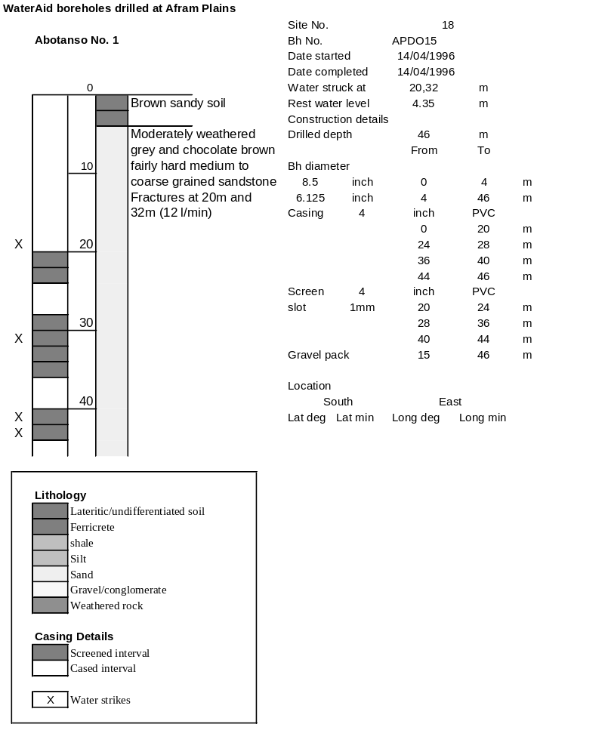

Ghana | Test pumping
Borehole No. |  | ADPO15
Hole No |  | 18
Village |  | Abotanso No 1
Date |  | 24/04/1996
Point above GL |  | 0.5 | m
Pump depth |  | 18 | m
SWL |  | 4.85 | m
Start Time |  | 07:40
Drawdown test |  |  |  |  | Recovery test
time | pwl (m) | Q l/min | dd | sc | Time | wl (m) | s' | t/t'
0.00 | 4.85 | 15.00 | 0.00 |  | 0.00 | 14.13 | 9.28
1.00 | 7.69 | 15.00 | 2.84 | 5.28 | 1.00 | 11.57 | 6.72 | 181.00
2.00 | 7.63 | 15.00 | 2.78 | 5.40 | 2.00 | 9.35 | 4.50 | 91.00
3.00 | 7.60 | 15.00 | 2.75 | 5.45 | 3.00 | 7.79 | 2.94 | 61.00
4.00 | 7.73 | 15.00 | 2.88 | 5.21 | 4.00 | 6.70 | 1.85 | 46.00
5.00 | 8.20 | 15.00 | 3.35 | 4.48 | 5.00 | 6.03 | 1.18 | 37.00
6.00 | 8.43 | 15.00 | 3.58 | 4.19 | 6.00 | 5.72 | 0.87 | 31.00
7.00 | 8.60 | 15.00 | 3.75 | 4.00 | 7.00 | 5.60 | 0.75 | 26.71
8.00 | 8.74 | 15.00 | 3.89 | 3.86 | 8.00 | 5.56 | 0.71 | 23.50
9.00 | 8.82 | 15.00 | 3.97 | 3.78 | 9.00 | 5.54 | 0.69 | 21.00
10.00 | 8.88 | 15.00 | 4.03 | 3.72 | 10.00 | 5.53 | 0.68 | 19.00
11.00 | 8.92 | 15.00 | 4.07 | 3.69 | 12.00 | 5.51 | 0.66 | 16.00
12.00 | 8.94 | 15.00 | 4.09 | 3.67 | 14.00 | 5.50 | 0.65 | 13.86
13.00 | 8.95 | 15.00 | 4.10 | 3.66 | 16.00 | 5.49 | 0.64 | 12.25
14.00 | 8.95 | 15.00 | 4.10 | 3.66 | 18.00 | 5.48 | 0.63 | 11.00
15.00 | 9.10 | 15.00 | 4.25 | 3.53 | 20.00 | 5.47 | 0.62 | 10.00
16.00 | 9.25 | 15.00 | 4.40 | 3.41 | 22.00 | 5.46 | 0.61 | 9.18
17.00 | 9.30 | 15.00 | 4.45 | 3.37 | 24.00 | 5.45 | 0.60 | 8.50
18.00 | 9.31 | 15.00 | 4.46 | 3.36 | 26.00 | 5.45 | 0.60 | 7.92
19.00 | 9.33 | 15.00 | 4.48 | 3.35 | 28.00 | 5.44 | 0.59 | 7.43
20.00 | 9.35 | 15.00 | 4.50 | 3.33 | 30.00 | 5.44 | 0.59 | 7.00
22.00 | 9.77 | 15.00 | 4.92 | 3.05 | 35.00 | 5.43 | 0.58 | 6.14
24.00 | 10.20 | 15.00 | 5.35 | 2.80 | 40.00 | 5.42 | 0.57 | 5.50
26.00 | 10.45 | 15.00 | 5.60 | 2.68 | 45.00 | 5.42 | 0.57 | 5.00
28.00 | 10.60 | 15.00 | 5.75 | 2.61 | 50.00 | 5.41 | 0.56 | 4.60
30.00 | 10.71 | 15.00 | 5.86 | 2.56 | 60.00 | 5.40 | 0.55 | 4.00
35.00 | 10.92 | 15.00 | 6.07 | 2.47 | 70.00 | 5.40 | 0.55 | 3.57
40.00 | 10.98 | 15.00 | 6.13 | 2.45 | 80.00 | 5.38 | 0.53 | 3.25
45.00 | 10.99 | 15.00 | 6.14 | 2.44 | 90.00 | 5.37 | 0.52 | 3.00
50.00 | 11.17 | 15.00 | 6.32 | 2.37 | 100.00 | 5.36 | 0.51 | 2.80
55.00 | 11.23 | 15.00 | 6.38 | 2.35 | 110.00 | 5.36 | 0.51 | 2.64
60.00 | 11.60 | 15.00 | 6.75 | 2.22 | 120.00 | 5.35 | 0.50 | 2.50
70.00 | 12.58 | 15.00 | 7.73 | 1.94
80.00 | 13.15 | 15.00 | 8.30 | 1.81
90.00 | 13.30 | 15.00 | 8.45 | 1.78
100.00 | 13.53 | 15.00 | 8.68 | 1.73
110.00 | 13.55 | 15.00 | 8.70 | 1.72
120.00 | 13.70 | 15.00 | 8.85 | 1.69
130.00 | 13.82 | 15.00 | 8.97 | 1.67
140.00 | 13.86 | 15.00 | 9.01 | 1.66
160.00 | 14.01 | 15.00 | 9.16 | 1.64
180.00 | 14.13 | 15.00 | 9.28 | 1.62
